**# Internship FAQ Chatbot – Deployment Guide**

This guide explains the step-by-step process to create an **\*\*Internship FAQ Chatbot\*\*** using **\*\*Dialogflow ES\*\*** and connect it to a website using **\*\*Live Server\*\***.

---

**## 🚀 Steps to Create the Chatbot**

**### 1. Dialogflow Setup**

- Go to [Dialogflow Console](https://dialogflow.cloud.google.com).

- Create a new agent called **\*\*InternshipFAQChatBot\*\***.

- Set language to **\*\*English\*\*** and default time zone to your local region.

**### 2. Add Intents**

**-showing options default call back intent and default welcome intent**

- Create an intent with name `WELCOME`.

- In the Training Phrases section, add greetings like:

  - "hi"

  - "hello"

  - "how can you help me?"

- In Responses, write something like:

  - "Hello! How can I assist you regarding internships?"

**### 3. Add Knowledge Base**

- Navigate to **\*\*Knowledge (beta)\*\***.

- Create a new knowledge base: `Internship_knowledgebase`.

- Upload a `.csv` file with internship-related Q&A like internship providers, duration, and details.

- Make sure to map questions and answers properly.

**### 4. Enable Integrations**

- Go to **\*\*Integrations\*\*** → Enable **\*\*Dialogflow Messenger\*\***.

- Copy the embed code:

```html

<script src="https://www.gstatic.com/dialogflow-console/fast/messenger/bootstrap.js?v=1"></script>

<df-messenger

  intent="WELCOME"

  chat-title="InternshipFAQChatBot"

  agent-id="YOUR_AGENT_ID"

  language-code="en">

</df-messenger>

**## 🌐 Connecting to Website**

**### 5. Create a Basic HTML File**

```html

<!DOCTYPE html>

<html>

<head>

  <title>Internship AI Chatbot</title>

</head>

<body>

  <h1>Welcome to Internship Helpdesk</h1>

  <p>Ask about internships from Infosys, Cisco, Google, and more!</p>

  <!-- Dialogflow Chatbot -->

  <script src="https://www.gstatic.com/dialogflow-console/fast/messenger/bootstrap.js?v=1"></script>

  <df-messenger

    intent="WELCOME"

    chat-title="InternshipFAQChatBot"

    agent-id="YOUR_AGENT_ID"

    language-code="en">

  </df-messenger>

</body>

</html>

**### 6. Add Images (Optional)**

- Download internship-related or company images (Infosys, Cisco, MICS).

- Add `<img src="filename.jpg">` to your HTML.

**## 🧪 Run with Live Server**

- Open your project folder in **\*\*VS Code\*\***.

- Save your HTML file as `index.html`.

- Right-click → `Open with Live Server`.

You’ll see your chatbot on the right bottom corner. It will respond based on knowledge base and training.

---

**## 📷 Screenshots**

![Chatbot Working]

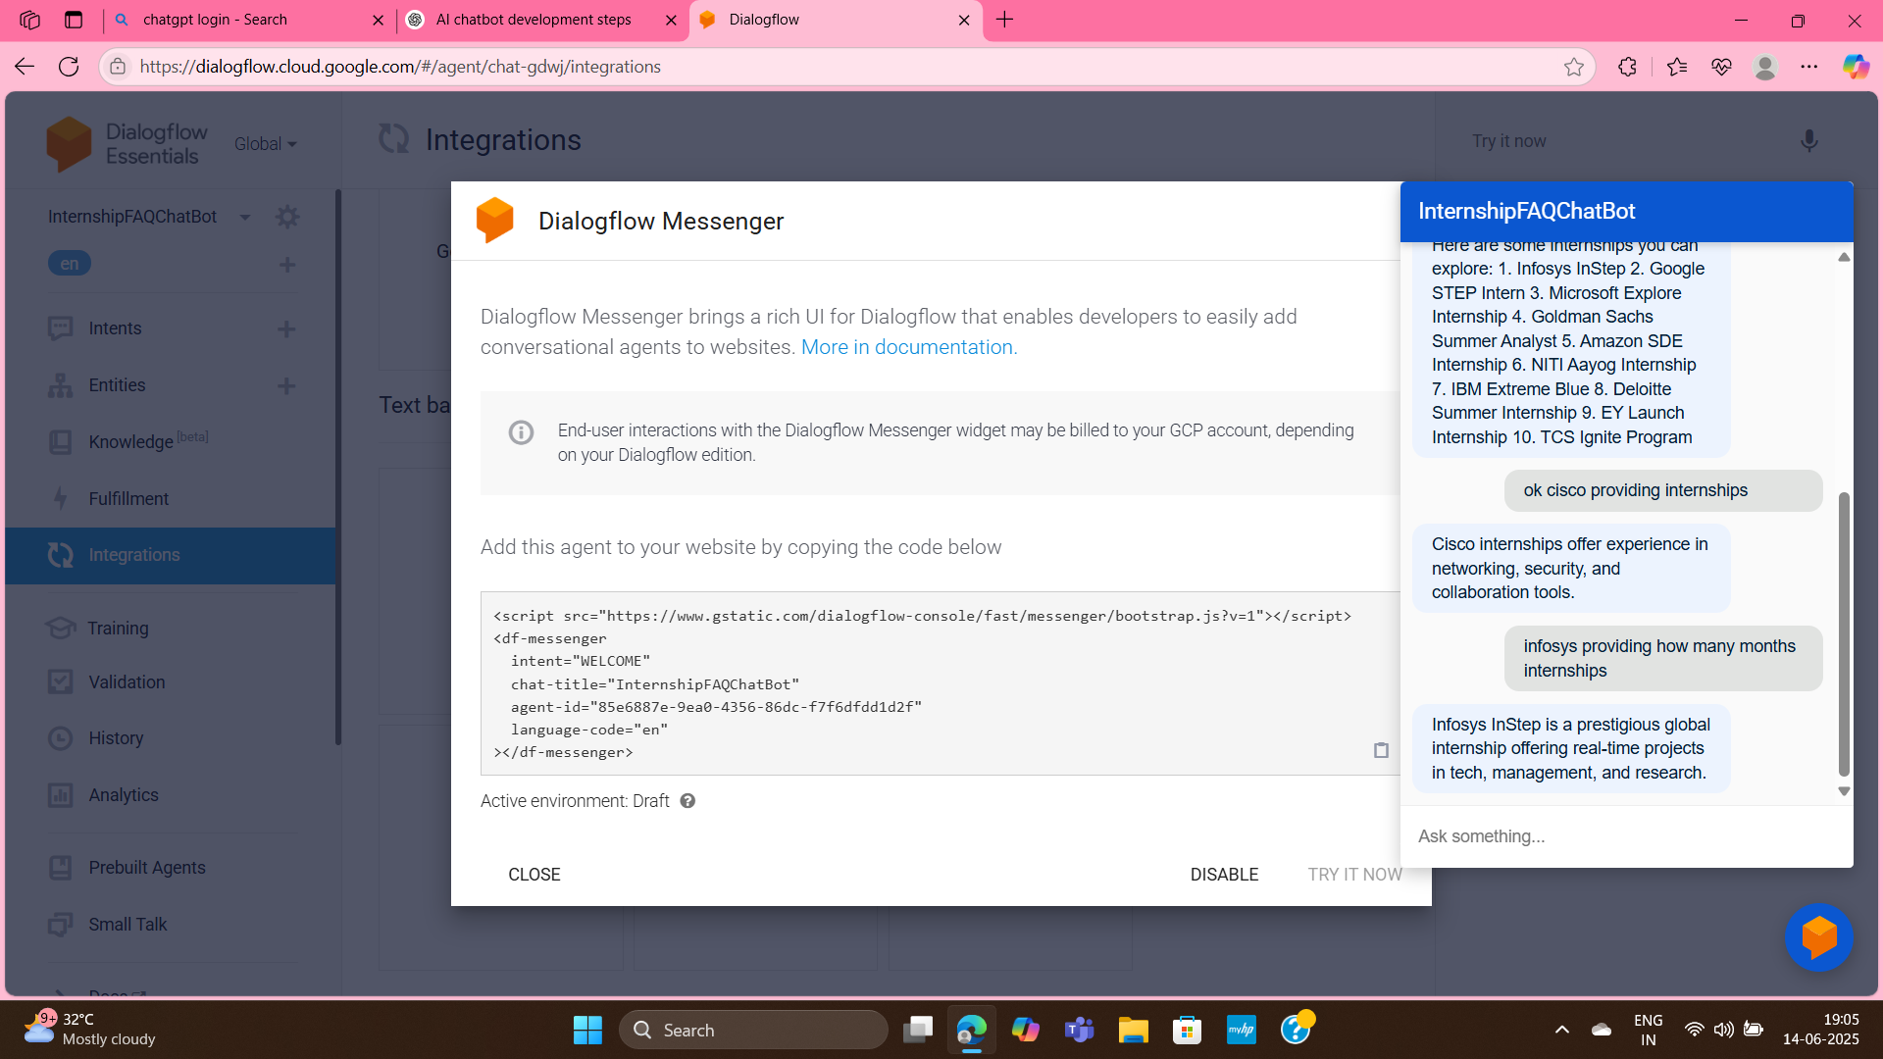

![Knowledge Base]

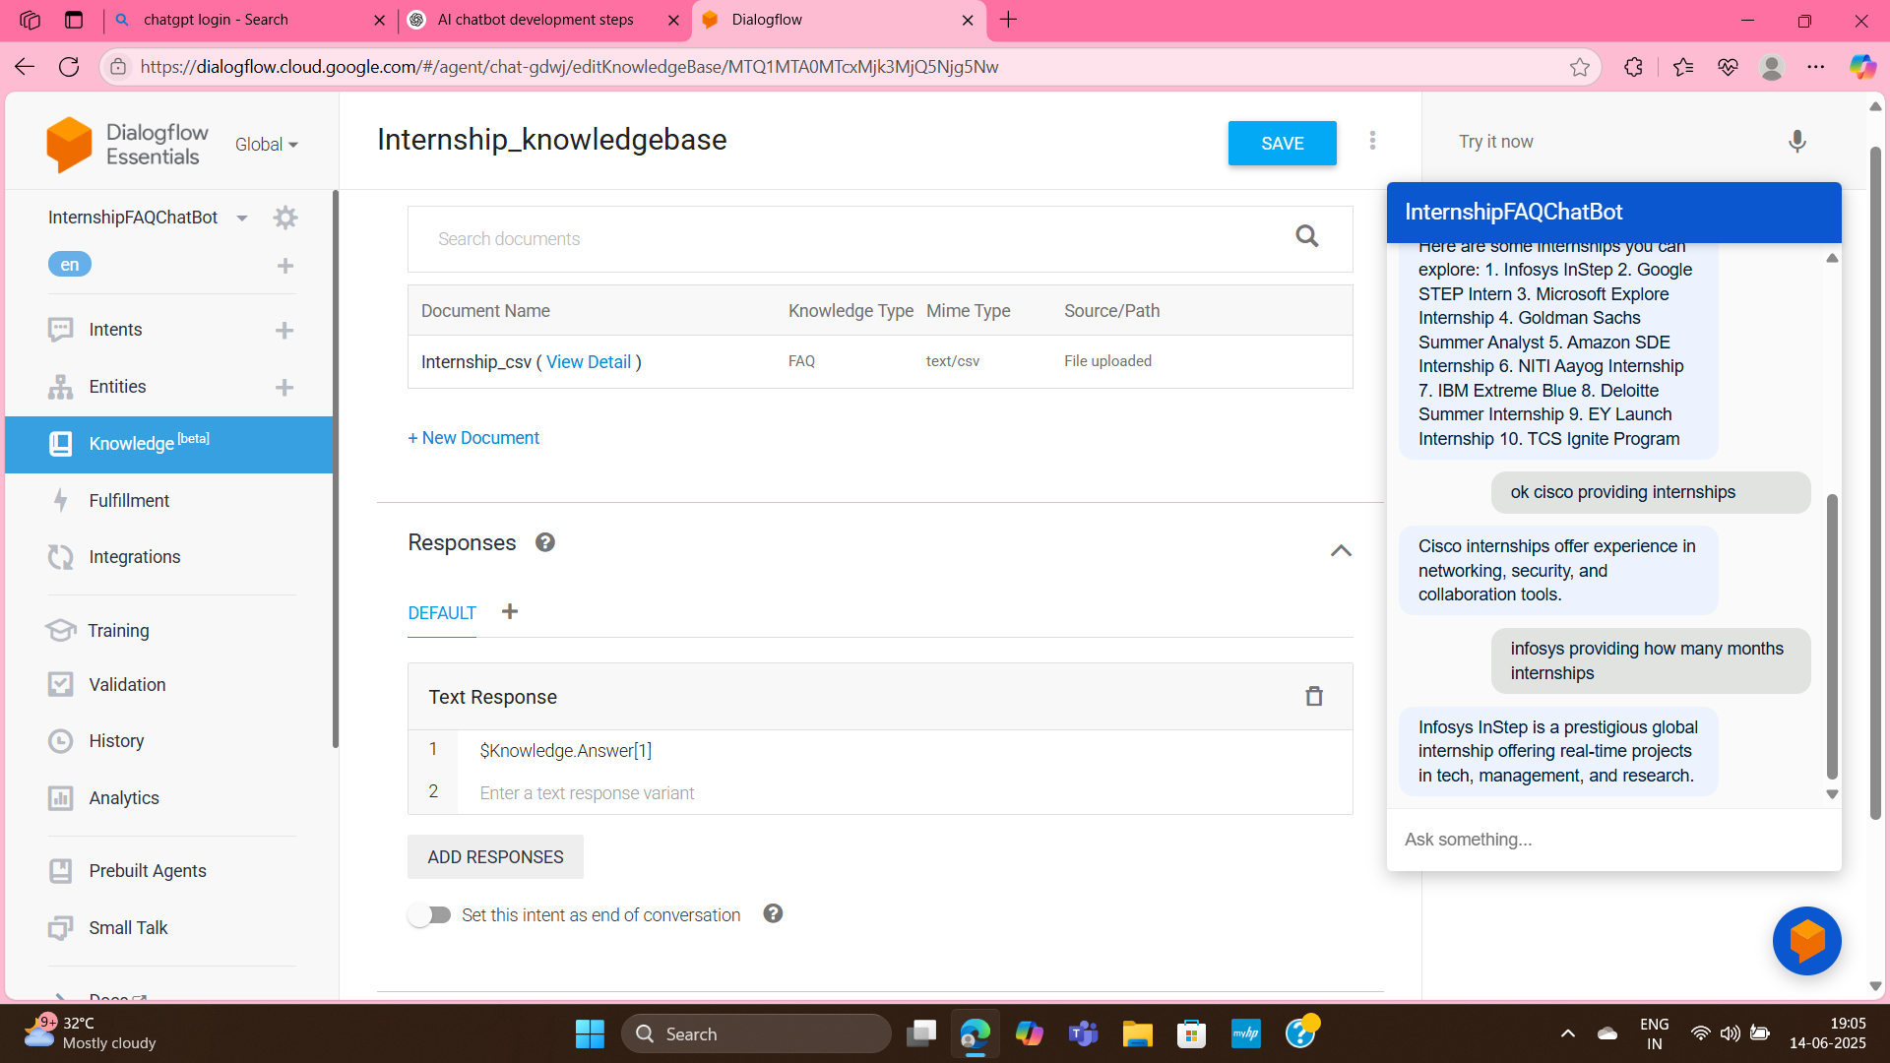

**## ✅ Final Output**

You now have a fully working internship chatbot that:

- Answers questions about internship companies.

- Shares details from a CSV-based knowledge source.

- Runs live on a webpage.

AI CHATBOT WEBSITE

